Lab6-Automatic Build: Using PyBuilder and using a Makefile for Python
Lab Exercise 1: Automating Builds with PyBuilder
Objective:
You will learn how to set up and use `PyBuilder` to automate the build process, manage dependencies, run tests, and package a Python project. Your project should look like something like this below, so follow the steps below:
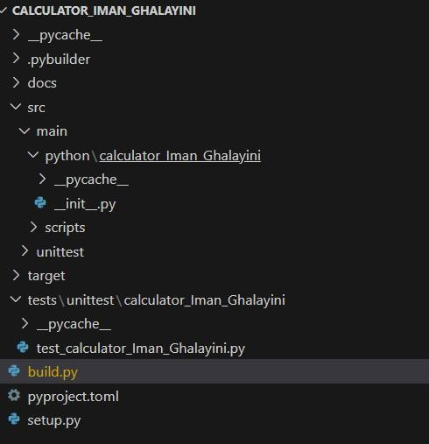

Prerequisites:
- Basic knowledge of Python programming
- Python and pip installed

Below is a step-by-step guide to creating a simple calculator project using PyBuilder, along with a graded exercise at the end.

Step-by-Step Lab: Building a Simple Calculator with PyBuilder

Step 1: Set Up the Project Structure

- Create a Project Directory:
Open your command prompt and create a new directory for your project:

mkdir calculator_FirstName_LastName cd calculator_FirstName_LastName

- Create Required Directories:
Inside the `calculator_FirstName_LastName` directory, create the following structure: mkdir src\main\python\calculator_Iman_Ghalayini

Step 2: Create the calculator_FirstName_LastName Functions
- Create the calculator_FirstName_LastName Module:
In the `src/main/python/calculator_FirstName_LastName` directory, create a file named ` init .py` and add the following basic calculator_FirstName_LastName functions:

src/main/python/calculator_FirstName_LastName/ init .py
def add(x, y): return x + y

def subtract(x, y): return x - y
def multiply(x, y):

return x * y
def divide(x, y): if y == 0:
raise ValueError("Cannot divide by zero.")


return x / y

Step 3: Create Unit Tests

- Create the Test File:
You need to create the below directories:’tests/unittest/calculator_FirstName_LastName`

In the `tests/unittest/calculator_FirstName_LastName` directory, create a file named
`test_calculator_FirstName_LastName.py` with the following content:

```python tests/unittest/calculator_FirstName_LastName/test_calculator_FirstName_LastName.py
import sys import os

# Add the src/main/python directory to the path

sys.path.insert(0, os.path.abspath(os.path.join(os.path.dirname( file ), '../../../src/main/python')))
import unittest

from calculator_FirstName_LastName import add, subtract, multiply, divide
class TestCalculator(unittest.TestCase): def test_add(self):
self.assertEqual(add(1, 2), 3) def test_subtract(self):
self.assertEqual(subtract(5, 3), 2)
def test_multiply(self):

self.assertEqual(multiply(3, 4), 12)
def test_divide(self):

self.assertEqual(divide(10, 2), 5)

with self.assertRaises(ValueError):
divide(10, 0)

if name == ' main ':

unittest.main()

Step 4: Create the `build.py` File

- Create the Build Descriptor:
In the root `calculator_FirstName_LastName` directory, create a file named `build.py` with the following content:

build.py
from pybuilder.core import use_plugin, init

use_plugin("python.core") use_plugin("python.unittest")
@init

def initialize(project):

project.set_property("name", "calculator_Iman_Ghalayini") project.set_property("version", "0.1") project.set_property("default_task", "publish")
project.set_property("unittest_module", "tests.unittest")

Step 5: Initialize and Run Tests with PyBuilder
- Initialize PyBuilder:
You may want to initialize the project if you haven't done so yet: pyb --start-project

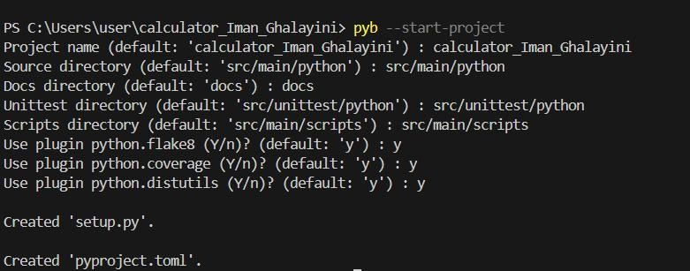
- Run Unit Tests:
From the project root directory, run the following command to execute your tests: pyb run_unit_tests
You should see output indicating that your tests passed.
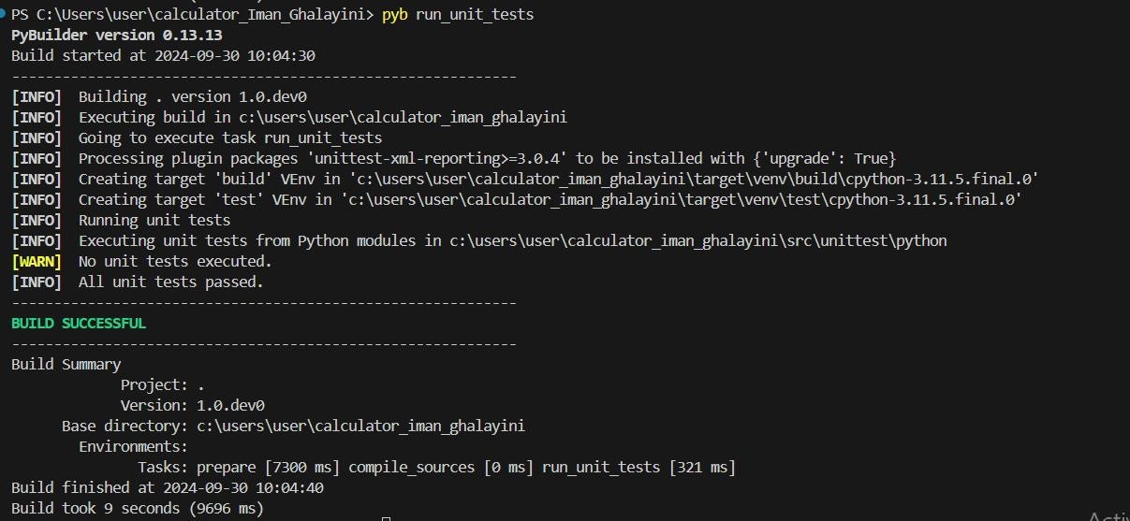

Step 6: Run All Tests
- Run All Tests:
You can also run all tests and check for issues with:

python -m unittest tests.unittest.calculator_FirstName_LastName.test_calculator_FirstName_LastName
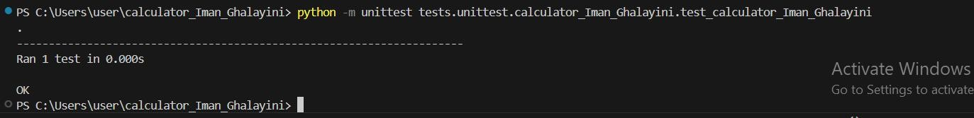

Exercise to be graded:
Now that you've built a simple calculator_FirstName_LastName, here’s an exercise for you to complete: Exercise: Extend the calculator_FirstName_LastName
- Add New Functions:
  - Implement a function for calculating the modulus (remainder).
  - Implement a function for exponentiation (power).
-Implement a function for calculating square root.
- Write Tests:
  - Create unit tests for the new functions in `test_calculator_FirstName_LastName.py`.
3. Run Your Tests:
- Use the `pyb run_unit_tests` command to ensure all tests pass. The output you receive is something like this:

Conclusion

By following this lab, you have created a simple calculator_FirstName_LastName project using PyBuilder, implemented functions, and set up unit tests. Your exercise is to extend this project with more features and tests as specified above

Expected Outcome
Upload to Moodle:
the fully automated Python project build process using PyBuilder.
The screenshot from terminal showing “Build finished…” stating your base directory(it has to show calculator_FirstName_LastName in it) and time taken same as the above snapshot.

Resource:
Complete walkthrough for a new PyBuilder project — PyBuilder 0.10 documentation

Optional Lab Exercise 2: Automating Python Builds with a Makefile
Note:This exercise is to develop your own knowledge and is not to be graded!
Objective:
You will learn how to create and use a `Makefile` to automate common tasks in a Python project, such as running tests, checking code style, and packaging the application.

Prerequisites:
- Basic knowledge of Python programming
- Python and `make` installed Steps:
- Project Setup:
  - Create a new directory for the project.
  - Inside the directory, create a basic Python script, e.g., `app.py`.

- Writing the Python Script:
  - Create a simple Python script in `app.py` using the python code below: def greet(name):
return f"Hello, {name}!"

if name == " main ": print(greet("World"))

- Creating a Makefile:
  - In the project directory, create a `Makefile` with the following content:
.PHONY: clean install test lint package
install:
pip install -r requirements.txt

test:
python -m unittest discover -s tests

lint:
flake8 app.py
clean:
find . -type f -name '.pyc' -delete rm -rf dist/

Faculty of Engineering and Architecture Software Tools Lab - Fall 2024-2025

package: python setup.py sdist bdist_wheel
- Setting Up Tests:
  - Create a `tests/` directory with a basic unit test for `app.py` using the python code below : tests/test_app.py
import unittest
from app import greet

class TestApp(unittest.TestCase):
def test_greet(self):
self.assertEqual(greet("World"), "Hello, World!")

if name == " main ":
unittest.main()

- Running Make Commands:
  - In the project directory, run the following commands to execute the tasks:
    - Install dependencies: `make install`
    - Run tests: `make test`
    - Lint the code: `make lint`
    - Clean up the project: `make clean`
    - Package the project: `make package`

- Discuss the `Makefile`:
  - Explain each target in the `Makefile` and how it simplifies repetitive tasks.
  - Discuss the benefits of using a `Makefile` in Python projects.

Expected Outcome:
You will have a Python project that uses a `Makefile` to automate tasks such as testing and packaging, providing a simple yet powerful way to manage project builds.
These lab exercises will give you practical experience in automating Python builds, making your workflows more efficient and reliable.

Exercise Overview

Set Up a Python Project:
  - Create a Python project structure.
  - Initialize a PyBuilder project.

Define Build Tasks with PyBuilder:
  - Configure tasks such as testing, packaging, and installing dependencies using PyBuilder.

Automate the Build Process with a Makefile:
  - Write a Makefile to automate the build, test, and clean processes.

Run the Build Process:

Faculty of Engineering and Architecture Software Tools Lab - Fall 2024-2025

Use the Makefile to build and manage the project.

Part 1: Setting Up the Python Project

Step 1: Create the Project Structure
- Create a directory named my_python_project.
- Inside my_python_project, create the following structure:
my_python_project/
│
├── src/

│ └── main/
│ └── python/
│ └── my_module.py
│
├── target/
│
└── build.py
- Create a simple Python module in my_module.py: def greet(name):
return f"Hello, {name}!"

Step 2: Initialize the PyBuilder Project
- Install PyBuilder if not already installed:
pip install pybuilder

- Navigate to your project directory and initialize PyBuilder:
cd my_python_project pyb --start-project
- Update the build.py file to include a basic build configuration:
from pybuilder.core import use_plugin, init

use_plugin("python.core") use_plugin("python.unittest") use_plugin("python.install_dependencies") use_plugin("python.distutils")
name = "my_python_project" version = "1.0"

@init
def initialize(project): project.set_property("dir_source_main_python", "src/main/python") project.set_property("dir_target", "target")
project.set_property("dir_source_unittest_python", "src/unittest/python")

project.build_depends_on("mock") project.build_depends_on("coverage")

Part 2: Define Build Tasks with PyBuilder

Faculty of Engineering and Architecture Software Tools Lab - Fall 2024-2025

Step 1: Add Unit Tests
Create a tests directory inside src/unittest/python.
2. Create a test file named test_my_module.py: import unittest
from my_module import greet
class TestMyModule(unittest.TestCase): def test_greet(self):
self.assertEqual(greet("World"), "Hello, World!") self.assertEqual(greet("PyBuilder"), "Hello, PyBuilder!")
if name == ' main ': unittest.main()

Step 2: Run PyBuilder
- In your project directory, run the following command to build and test the project:
pyb clean install_build_dependencies run_unit_tests
- Verify that the tests pass and the project is built correctly.

Part 3: Automate the Build Process with Makefile

Step 1: Create a Makefile
- In the root of your project directory, create a file named Makefile.
- Add the following content to automate the build process:
makefile
.PHONY: clean install_deps test build

clean:
pyb clean
install_deps:
pip install -r requirements.txt

test:
pyb run_unit_tests

build:
pyb package

all: clean install_deps test build

Step 2: Customize the Makefile
- Ensure the requirements.txt file exists in your project directory for dependency management.
- Customize the Makefile as needed to fit additional tasks you may want to automate.

Part 4: Run the Build Process

Step 1: Run Makefile Commands
- Use the following command to clean the project:
make clean
- Install dependencies using:

make install_deps

Faculty of Engineering and Architecture Software Tools Lab - Fall 2024-2025

make test
Run tests using:
- Build the project using:
make build
- To execute all tasks at once:
make all

Submission Guidelines
  - Code Files: Submit your complete my_python_project directory with all Python files,
build.py, and Makefile.
  - Documentation: Provide a brief explanation of the build process and how the Makefile automates it.

Expected Outcome for Exercise 2 (optional and not to be graded):
  - A fully automated Python project build process using PyBuilder and Makefile.
  - Familiarity with integrating PyBuilder into a project and using Makefile to streamline tasks.

